Sequential Circuits
A sequential circuit is a type of digital logic circuit whose output depends not only on the present value of its input signals but also on the sequence of past inputs. Because they rely on past history, sequential circuits inherently possess memory.

D – FlipFlop
A D (Data or Delay) Flip-Flop is a synchronous sequential logic circuit used to store a single bit of information. It is essentially a modified SR (Set-Reset) flip-flop with an added inverter to ensure the inputs are never the same, thereby eliminating the SR flip-flop's "invalid" state.

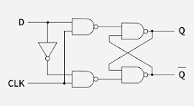

D – FlipFlop Output

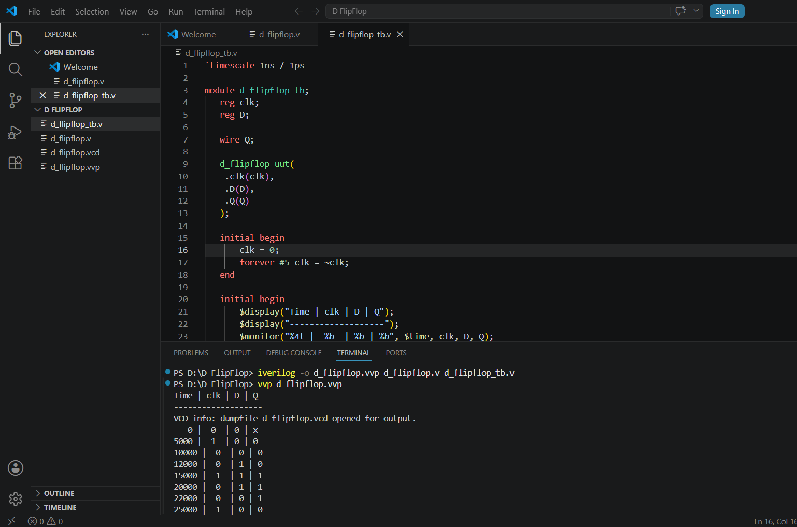

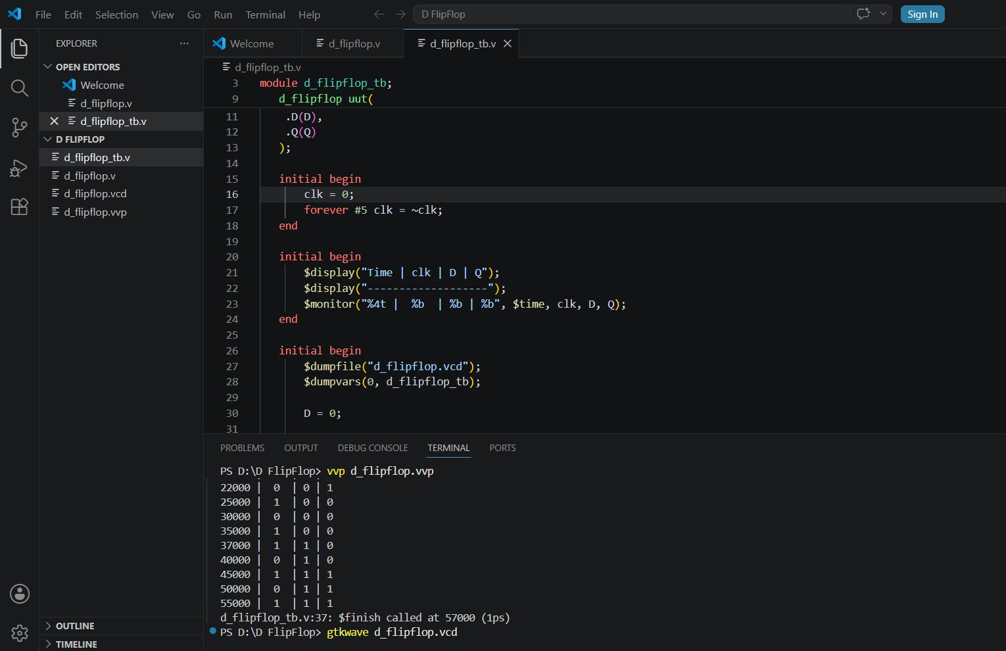

D – FlipFlop Waveform
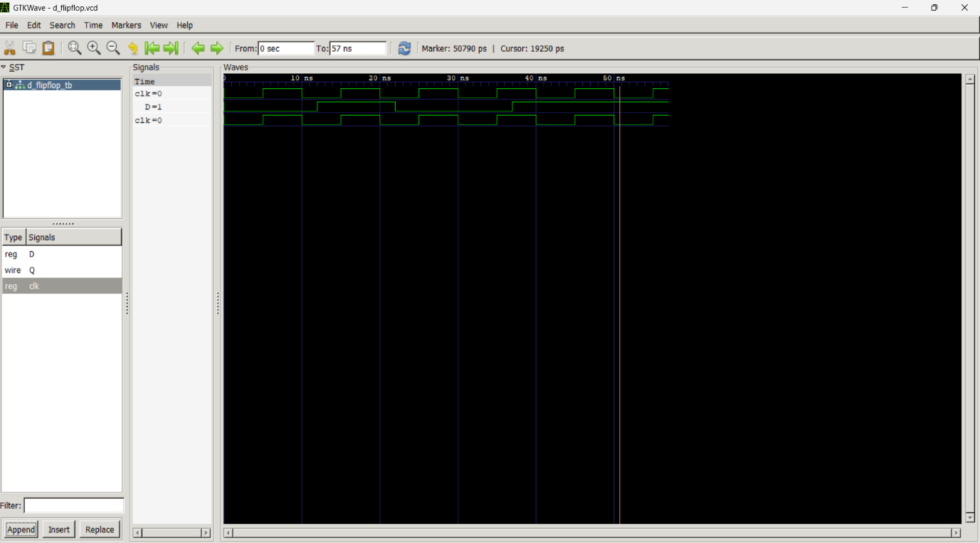
JK – FlipFlop
The JK flip-flop is a fundamental sequential logic circuit used in digital electronics to store a single bit of data. It is widely considered a universal flip-flop and is designed to improve upon the traditional SR (Set-Reset) flip-flop by completely eliminating its undefined or "invalid" state.
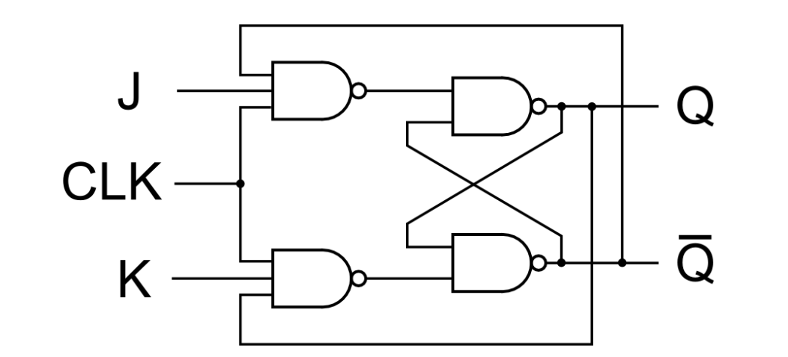

JK – FlipFlop Output
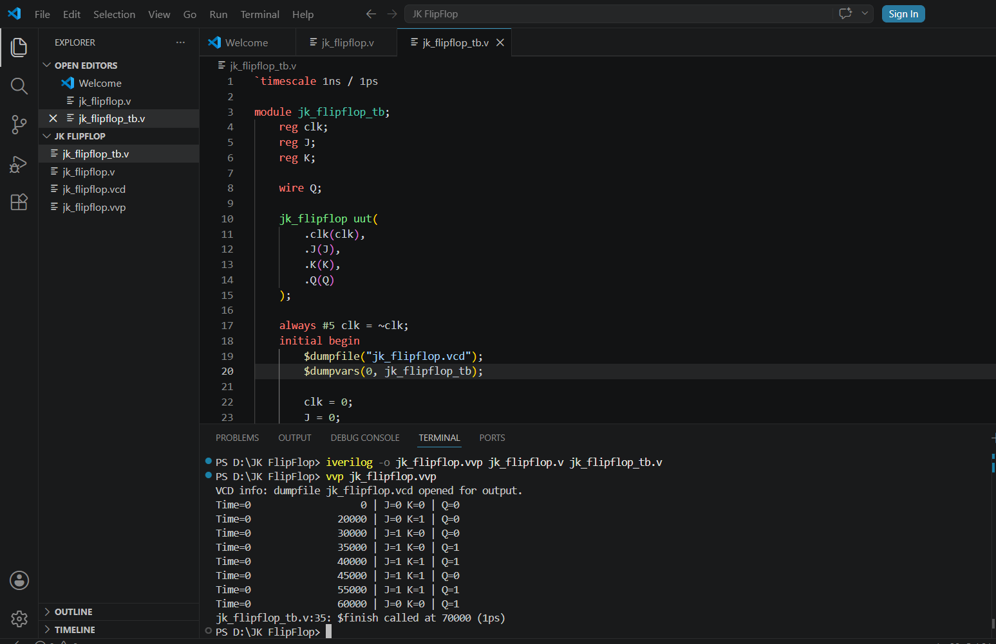
JK – FlipFlop Waveform
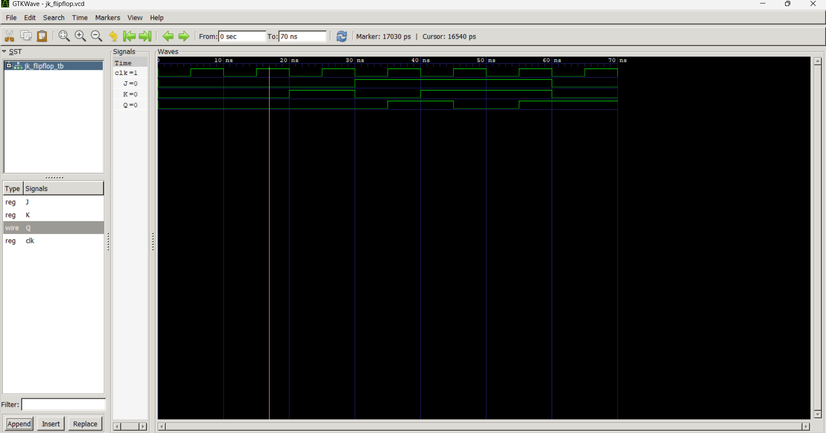

4 – Bit Register
A 4-bit register is a fundamental digital memory circuit designed to store and transfer four bits of binary data (often referred to as a nibble).

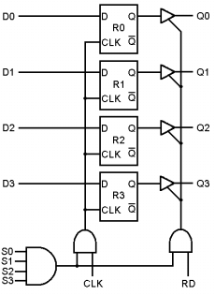

4 – Bit Register Output
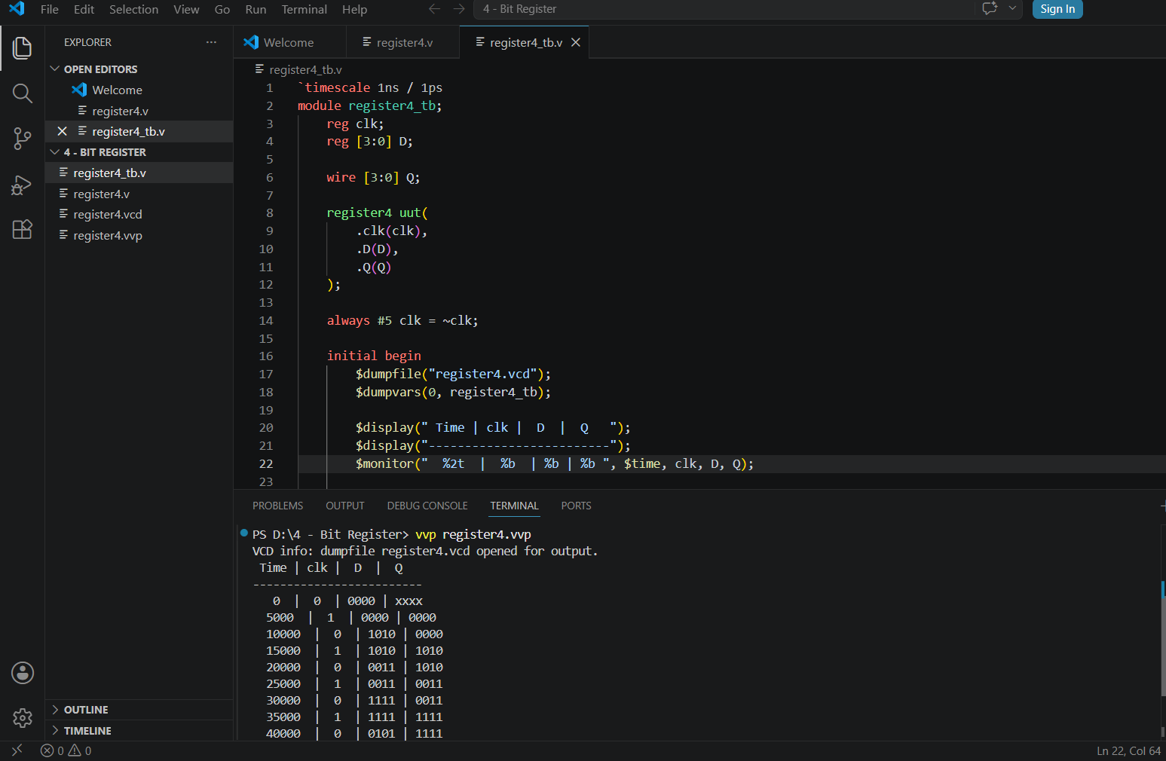

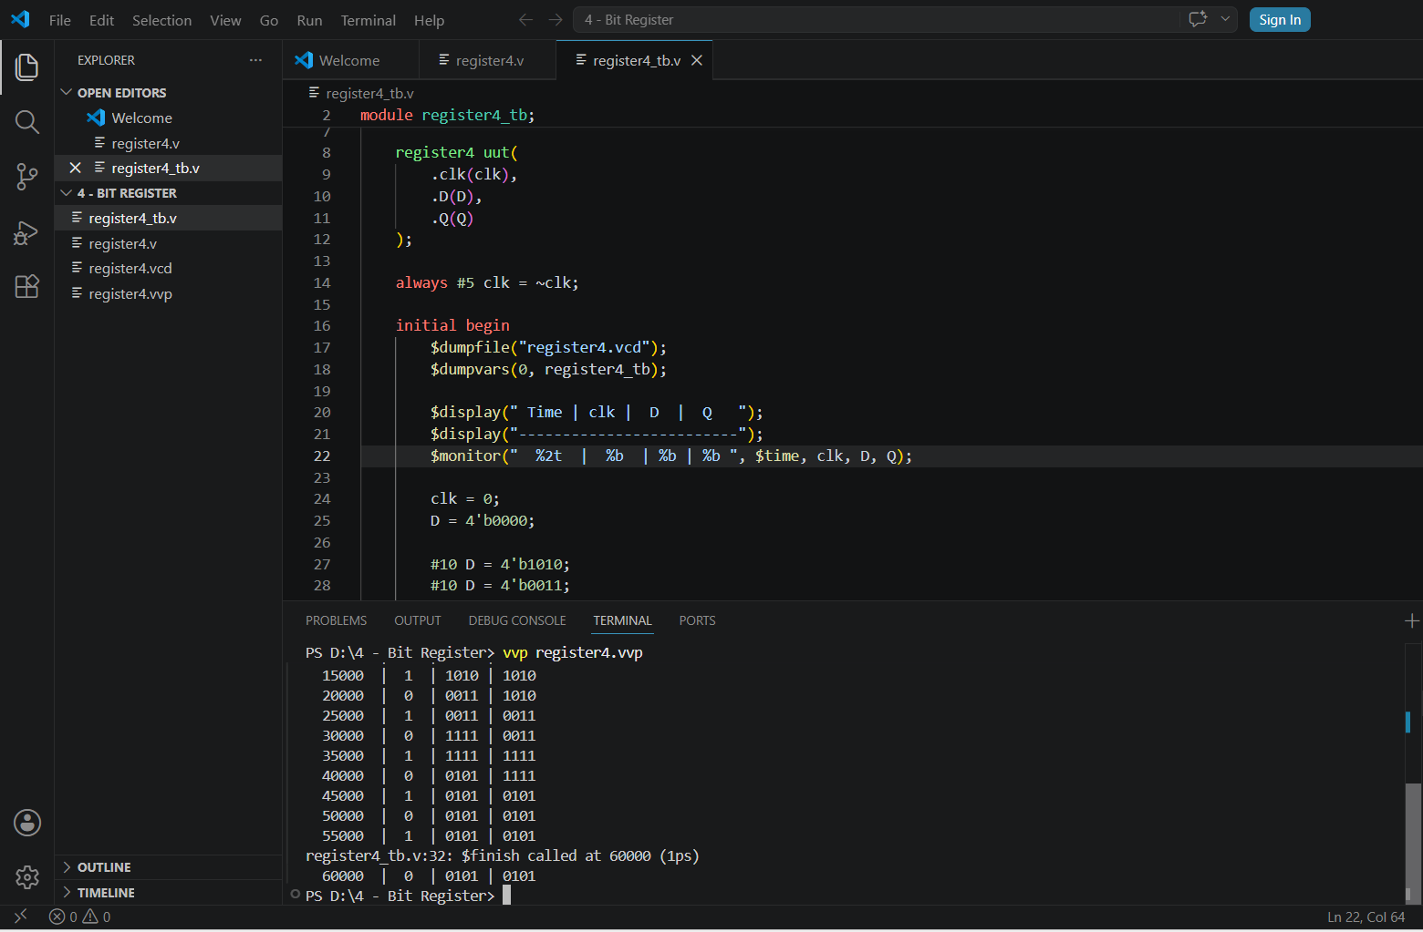

4 – Bit Register Waveform
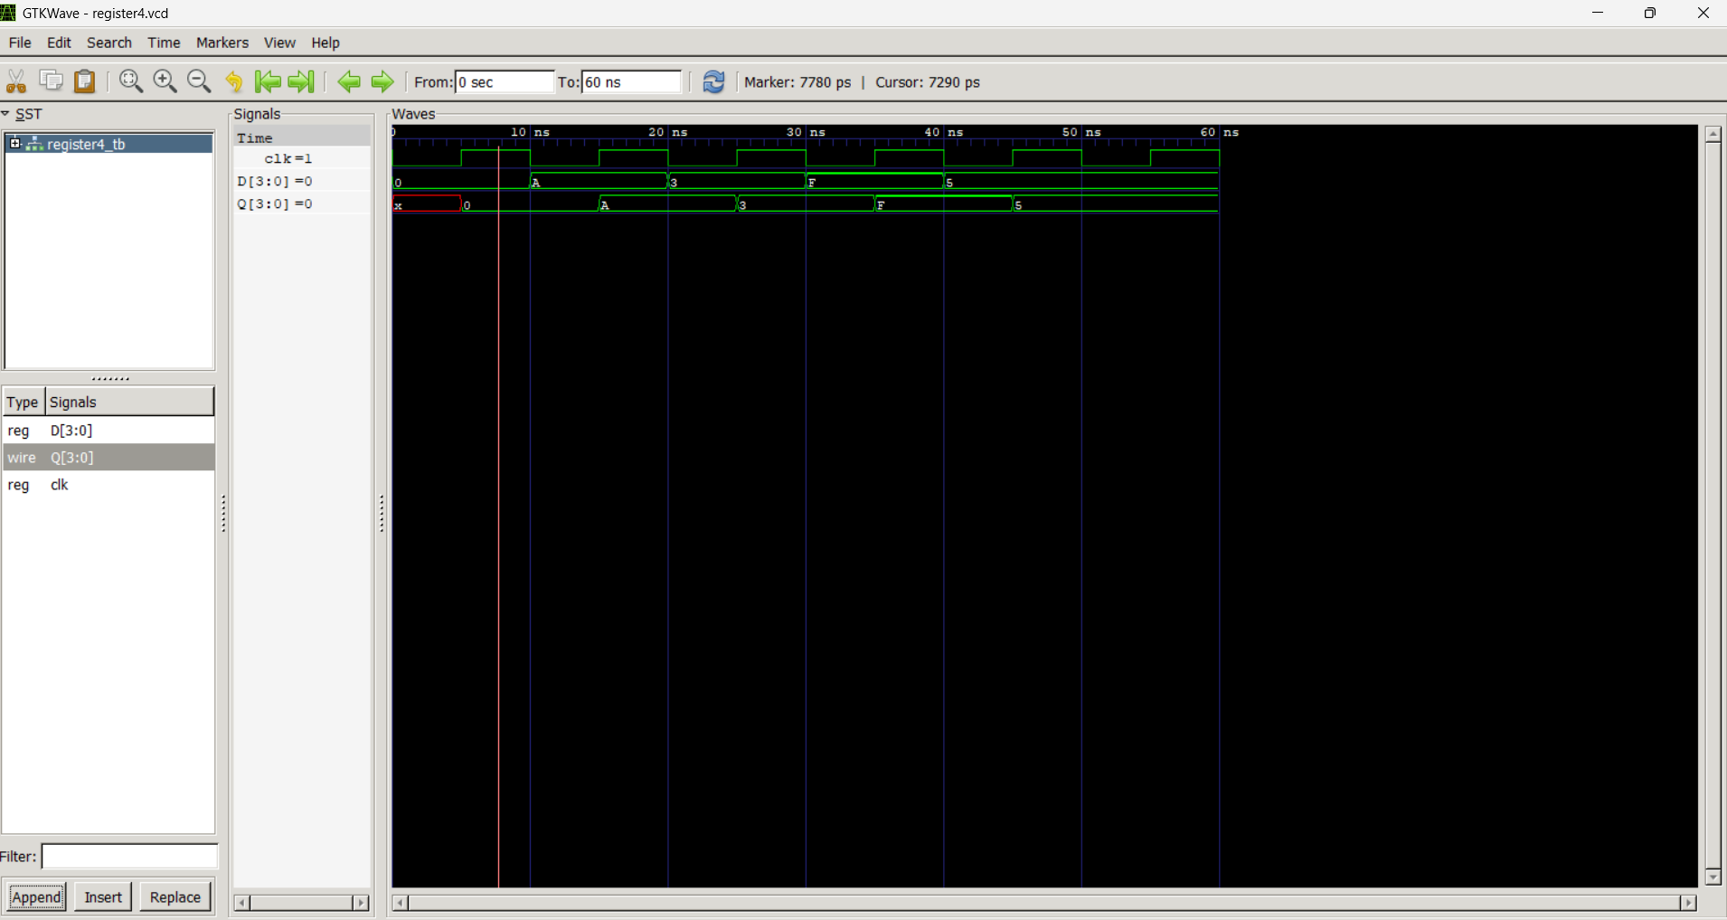

4 – Bit Counter
A 4-bit counter is a fundamental digital logic circuit designed to count from 0 to 15 in binary (0000 to 1111). Because it operates using 4 bits, it can hold 2^4 = 16 distinct states. Once the counter reaches its maximum value of 15 (1111), the very next clock pulse resets it back to 0 (0000) to start the sequence over again.

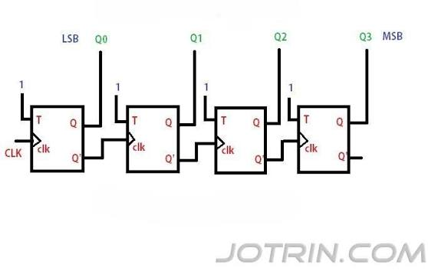

4 – Bit Counter Output
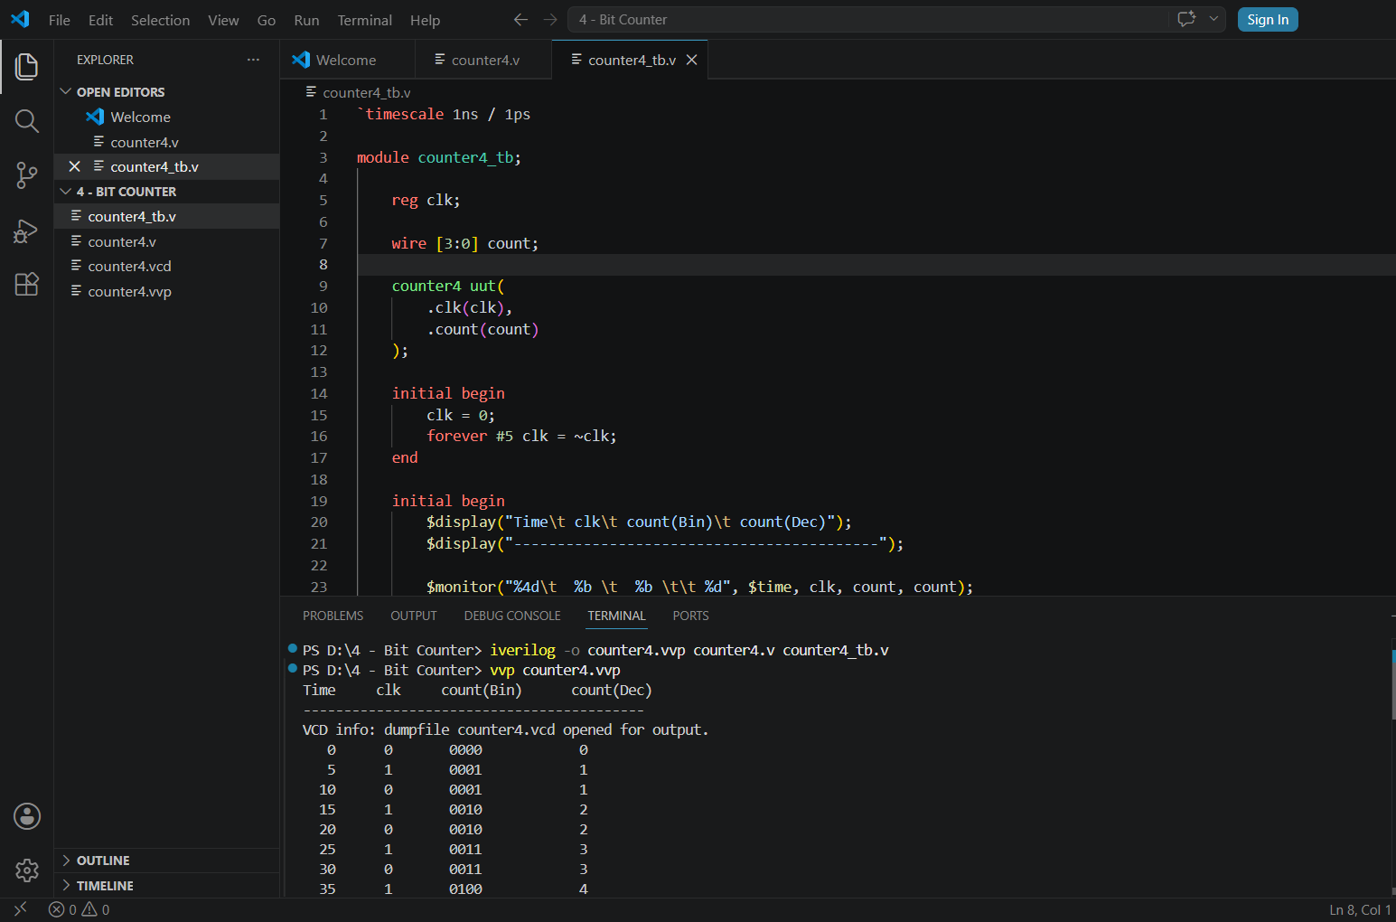
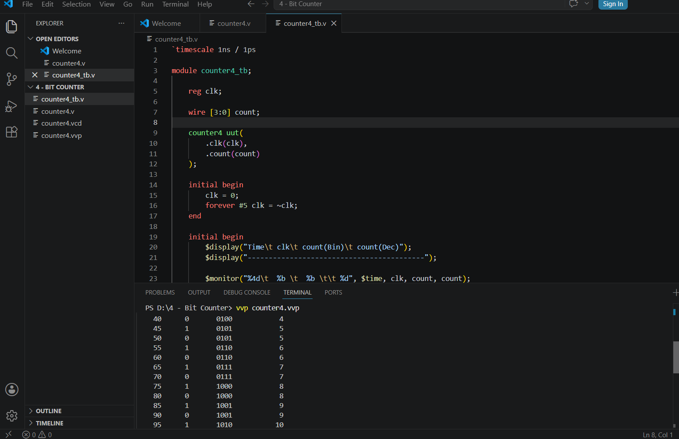
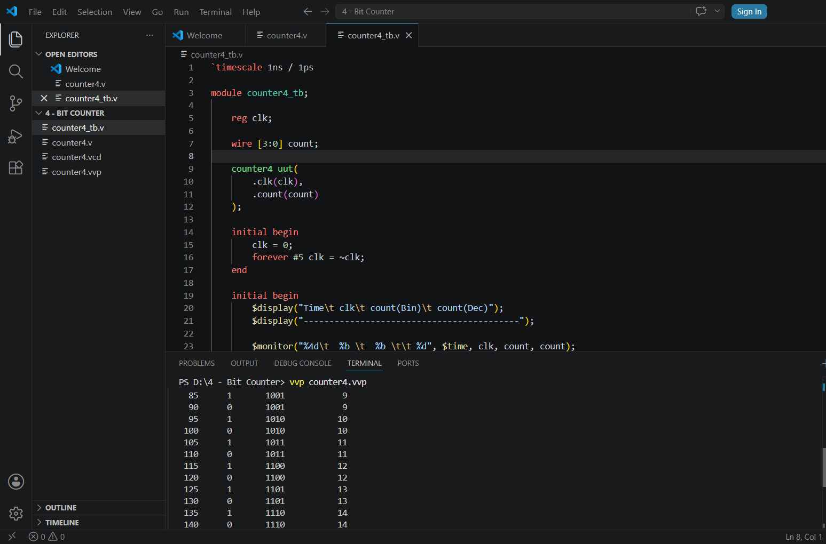
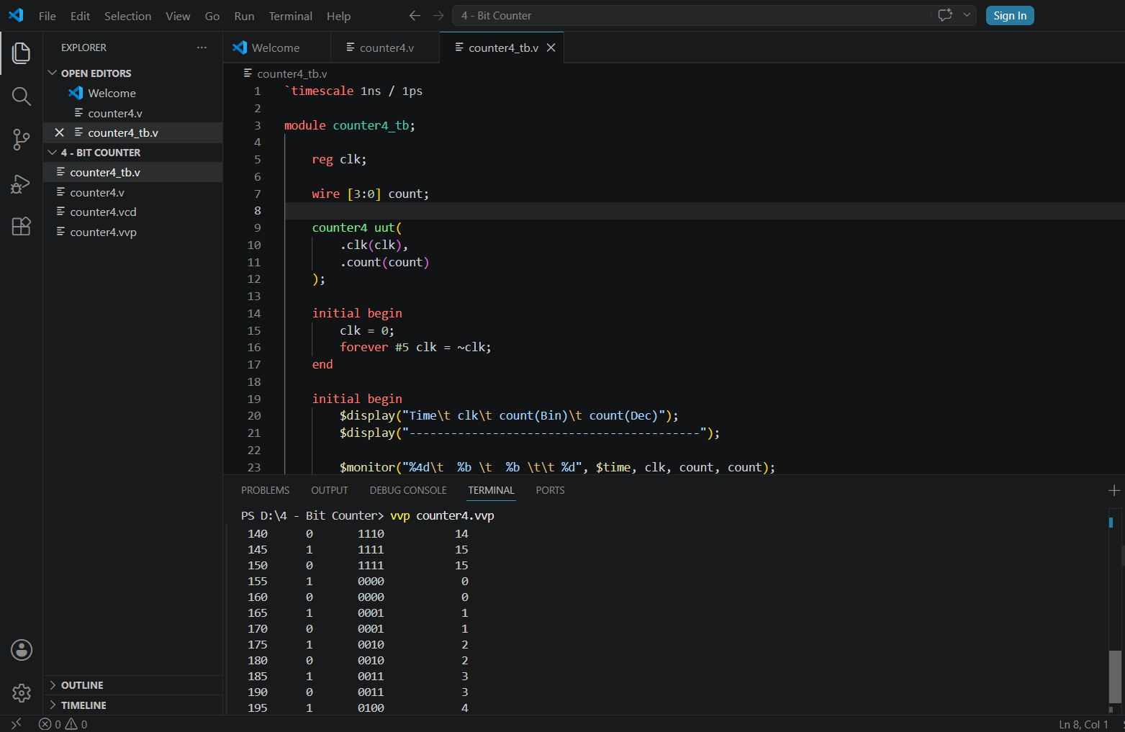
4 – Bit Counter Waveform
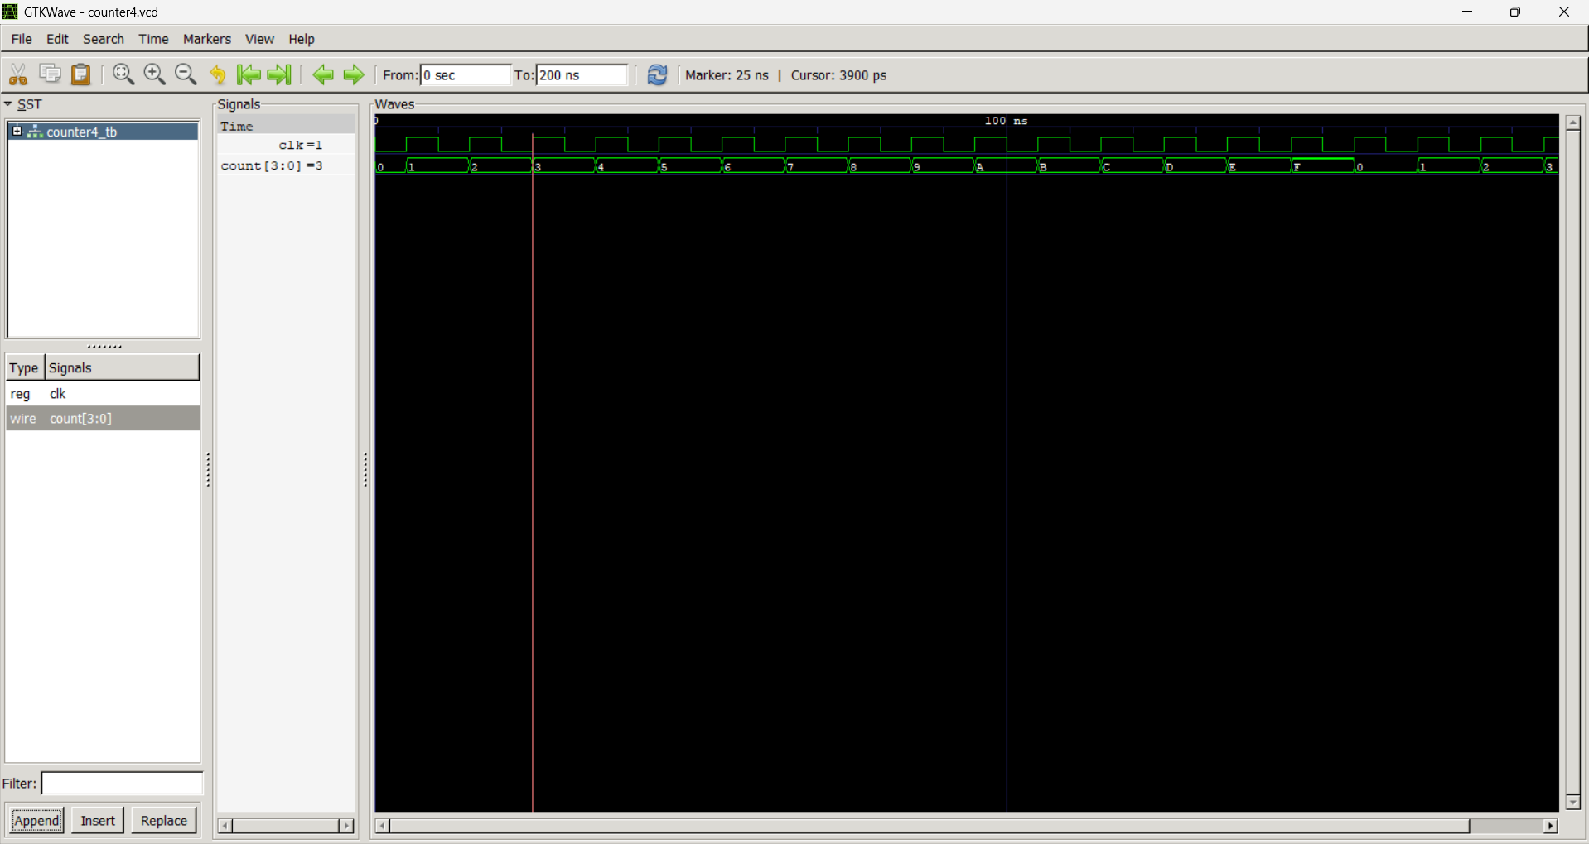

Observation
From this task, I have learnt about the sequential Circuits like D-FlipFlop, JK-FlipFlop, 4-Bit Register and 4-Bit Counter and it’s implementation in verilog.

